**Alpaca4d**

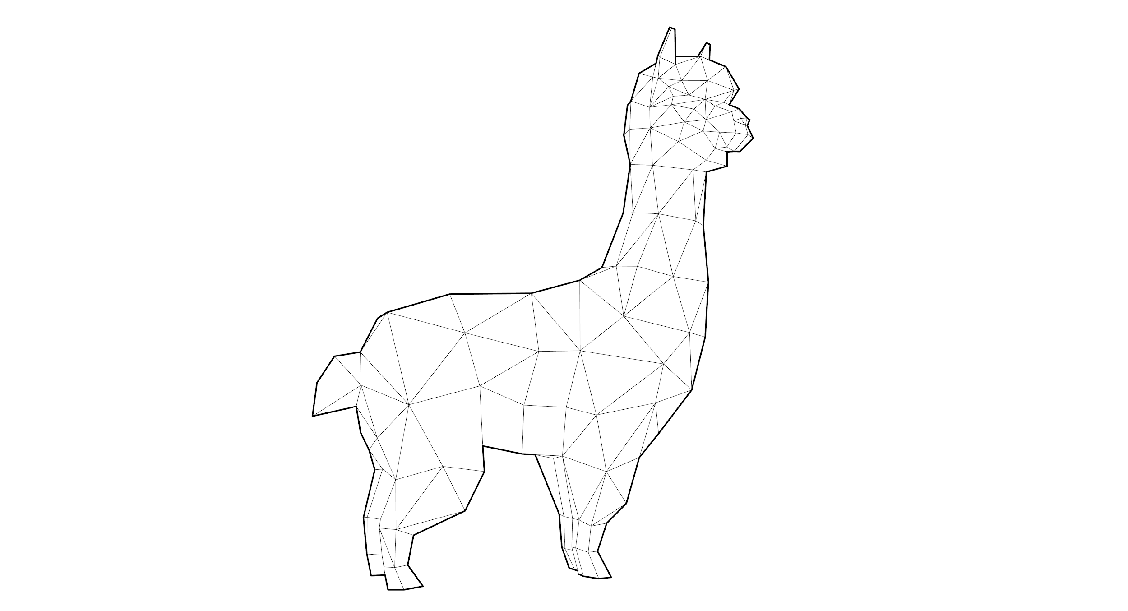

**Introduction**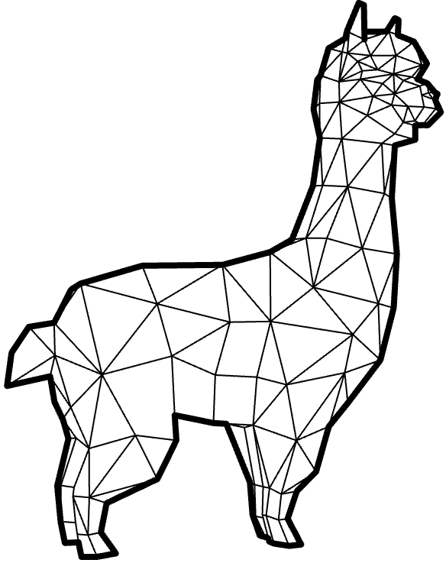

**Alpaca4d** is a Grasshopper plugin which has been developed on top of **OpenSees**.

The library is mostly used by researchers and academia because of the not user-friendly interface even if the math behind the library is highly sophisticated.

The main idea of **Alpaca4d** is to provide an efficient and easy way to use OpenSees without writing any line of code.

The belief is to bring more users to perform structural analyses with Opensees in a parametric environment such as Grasshopper.

Our main fields of interests are structural analysis, optimization, machine learning, geometry manipulation.

**Instagram**: [alpaca4d](https://www.instagram.com/alpaca4d/)

**Facebook**: [alpaca4d](https://www.facebook.com/Alpaca4d/)

**Mail**: [alpaca4d@gmail.com](mailto:alpaca4d@gmail.com)

**Installation**

Alpaca4d can be downloaded from: <https://www.food4rhino.com/app/Alpaca4d>

Follow the instructions to install Alpaca4d:

* Open Rhino and Grasshopper.
* Open the **Libraries folder**(Grasshopper -> File -> SpecialFolder -> Component Folder)

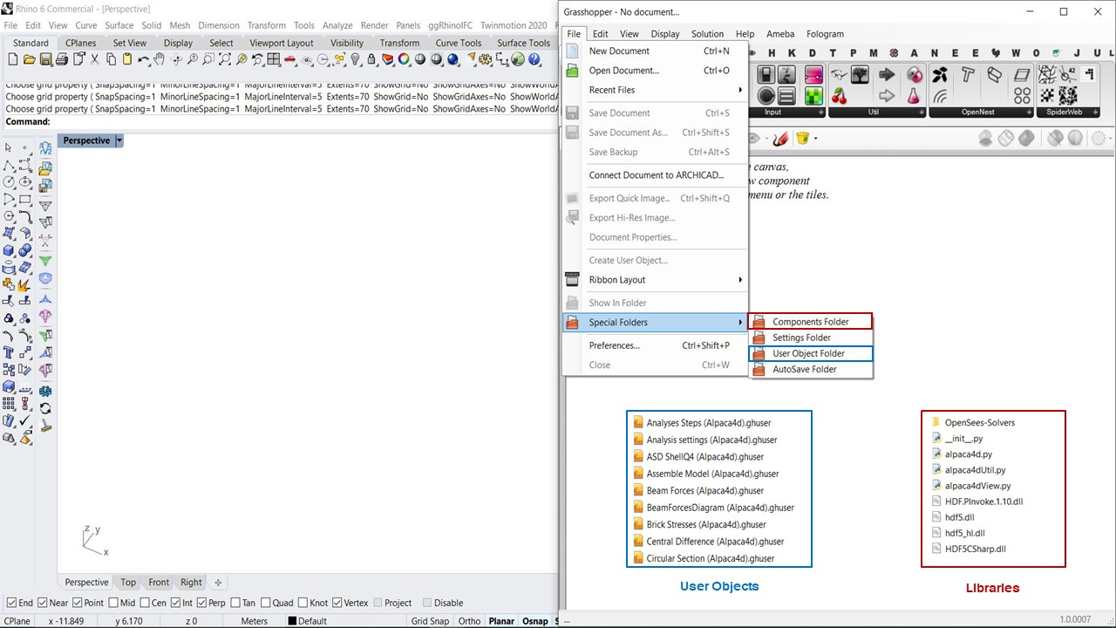

* Copy the folder "**Alpaca4d**" in the Grasshopper Libraries folder

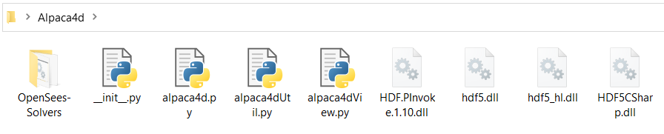

* Open the **User Object Folder**  
  (Grasshopper -> File -> Special Folder -> User Object Folder)
* Copy the **CONTENT** of the UserObjects folder into Grasshopper user objects folder

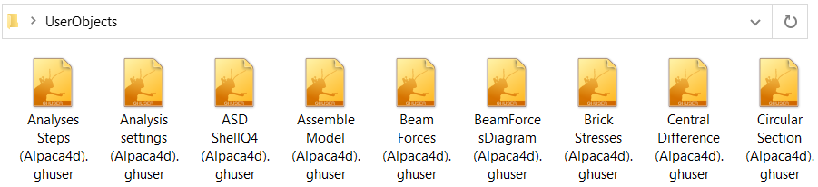

* Restart Rhino and Grasshopper.

**Alpaca4d** plugin will be found in the Alpaca4d tab of Grasshopper.



Figura 1 - Alpaca icons

**Material**

There are two families of material that you can define in Alpaca 4d: **UniaxialMaterial** and **NDMaterial**.

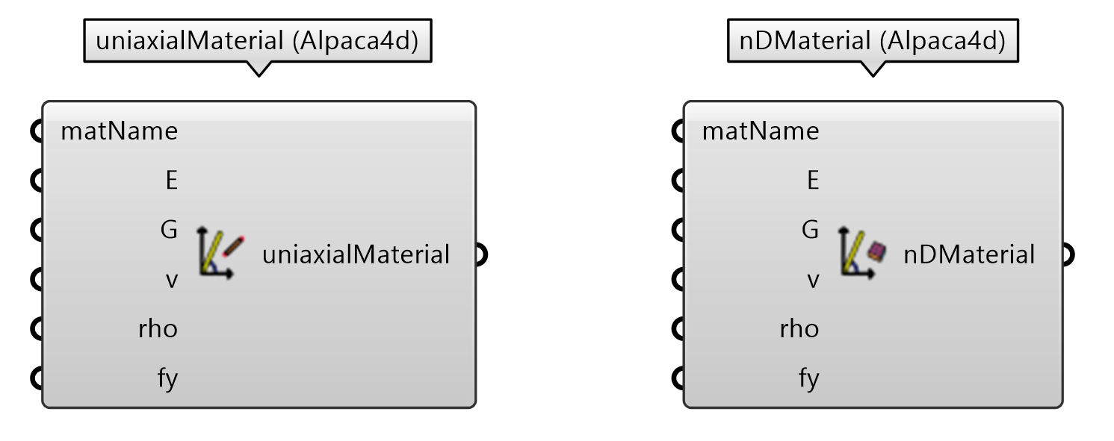

Figura 2 - Alpaca Materials

**UniaxialMaterial** is used to construct a material object which represents uniaxial stress-strain relationships. The implemented relationship is Linear Elastic.

**NDMaterial** is used to construct a material object which represents the stress-strain relationship at the gauss-point of a continuum element. The behaviour is an Elastic Isotropic.

**Cross-Section**

**Alpaca4d** offers several parametric cross section definitions for beams and shells.

Solid rectangle section, Circular Hollow Section, Rectangular Hollow Section, I-Section and Generic Cross Section are provided to the users to assign mechanical properties to a beam element.

Constant thickness section has been implemented for shell elements.

Figura 3 - Alpaca Cross Section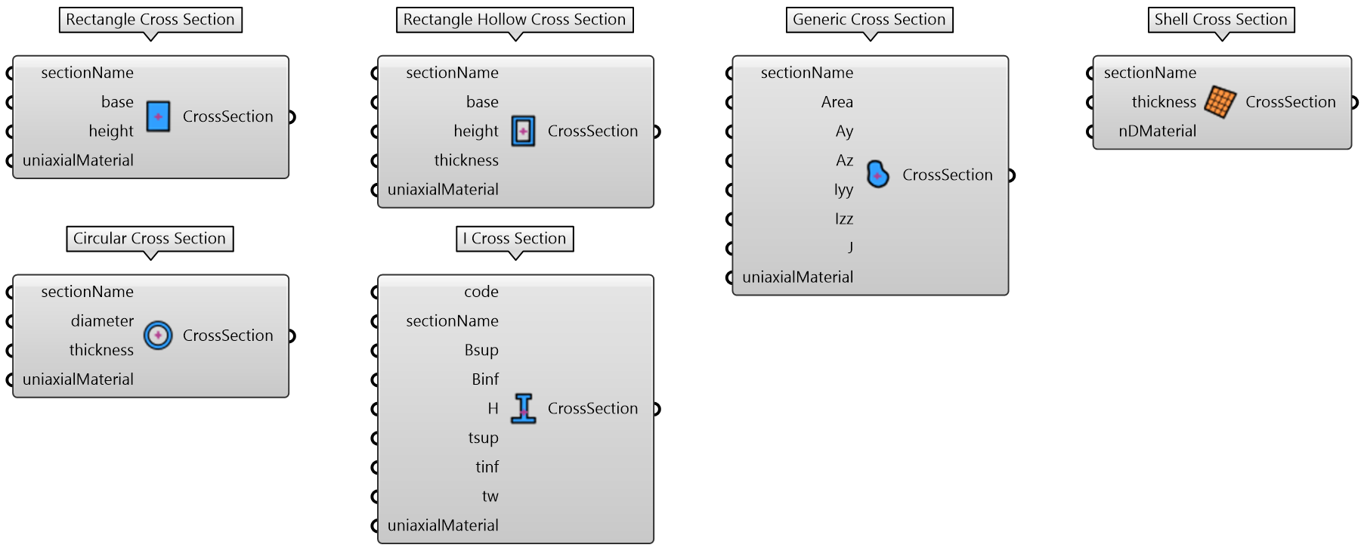

**Element**

The finite elements implemented are **Elastic Timoshenko Beam Column Element, ShellMITC4-ShellDKGT-ASDShellQ4, SSP Brick.**

**Line to Beam** component converts a line geometry to a Timoshenko Beam. Beam elements are used to model components in which one dimension (the length) is significantly greater than the other two dimensions and only the stress in the direction along the axis of the beam is significant. The cross section attached to it can be oriented using the *orientSection* input. *beamType* allows to release both ends in order to have an axial-only element (Truss).

**Mesh to Shell** component converts a mesh geometry to a **Shell Element.** Shell elements are used to model structures in which one dimension, the thickness, is significantly smaller than the other dimensions. Triangular faces will be converted to a **ShellDKGT** formulation and the Quad faces to a **ShellMITC4** formulation.

**Brick Element** component converts an hexahedral element into a **bbarBrick.** A hexahedron is any polyhedron with sixfaces. It is generally a difficult task to convert a generic solid into a set of hexahedron and **MeshSeriesToBrick** component might help to construct some simple polyhedron.

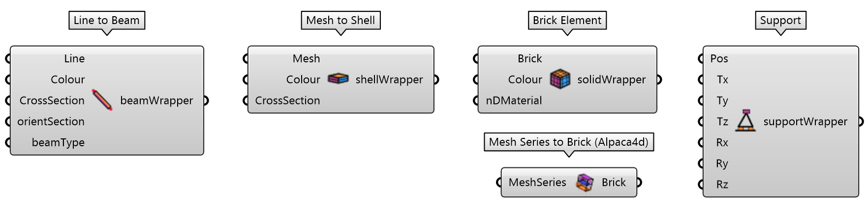

Figura 4 - Alpaca Elements

**Load**

**Gravity load** automatically applies the dead load on each element.

**Point load** defines a Force or Moment to a specific point of the structure.

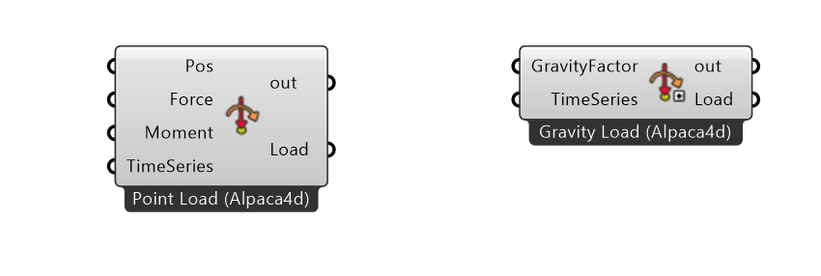

Figura 5 - Alpaca Loads

**Assemble**

Element and Support are the minimum input that the user should provide to perform an analysis.

**Assemble Model** builds a text file with the necessary information to be sent to OpenSees solver. The mass of the structure is automatically calculated from the assemble component.

**Disassemble Model** retrieves some text information to double check that the model has been assembled correctly.

**Visualise Model** is a graphical representation of the structure. The model output is either an extruded model or lines model.

Figura 6 - Alpaca Assemble/Disassemble and Visualize model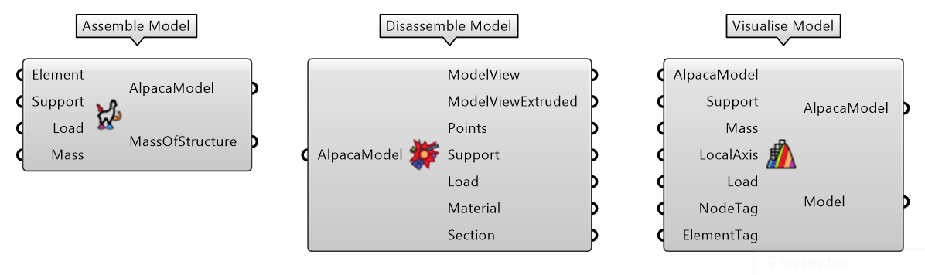

**Analyses**

Alpaca 4dcan perform Static Analysis, Modal analysis, Ground Motion Analysis and 3NDF Analyses (WIP-Brick Elements).

**Static Analysis** describes the response of the structure under a static load.

**Transient Analysis**

**Modal Analysis** computes the Modal shapes of the structure and returns the period and frequency of that mode.

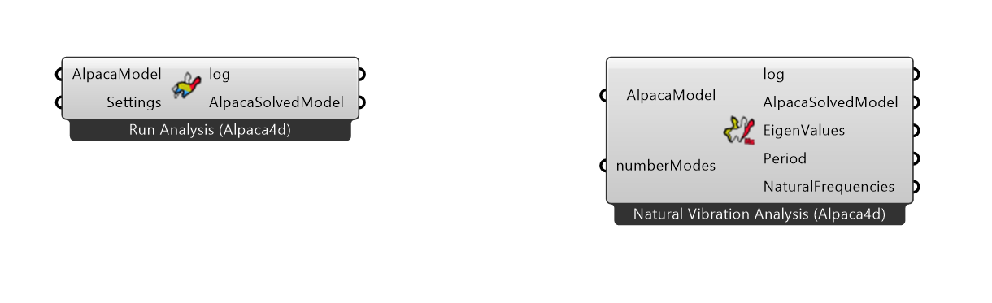

Figura 7 - Alpaca Analysis. Static, Transient, Modal Analysis.

**Numerical Computation and Visualization**

The static analysis returns the numerical outputs to study the behaviour of the structure. It is possible to query results for Point, Beam, Shell and Brick elements.

The visualization tools have been implemented for all types of analyses.

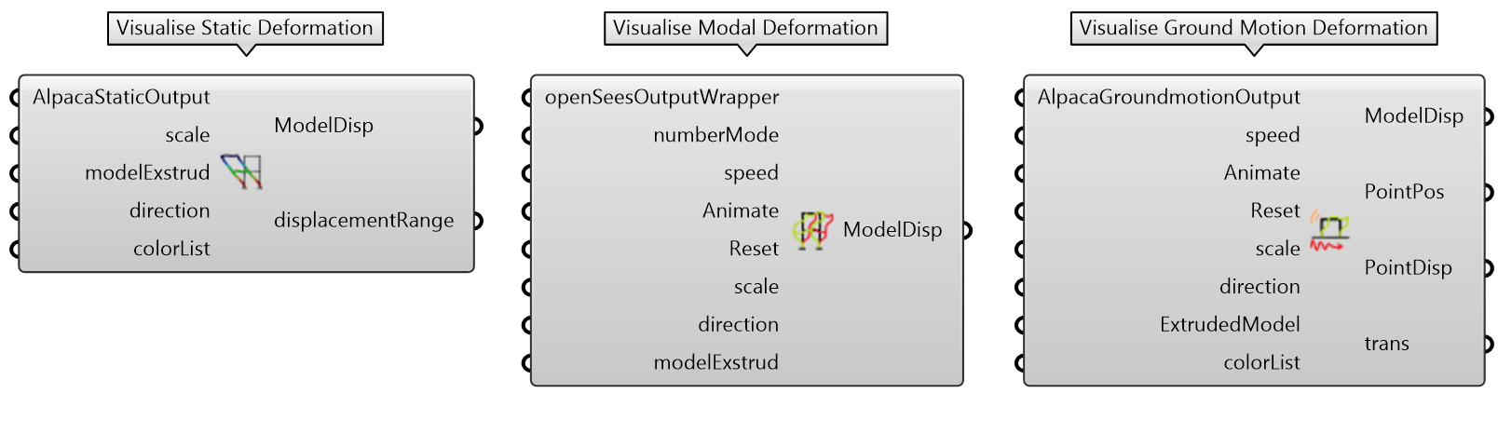Figura 8 - Alpaca Numerical and Visualisation.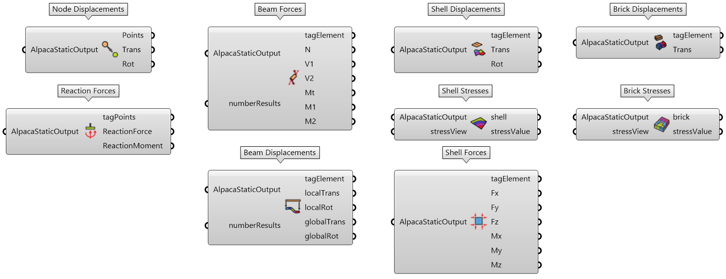

**Future Work**

There is still a lot of work to be done and we will try as hard as possible to keep working on the development.

Future development:

* Non Linear Material
* Non Linear Elements (concentrated plastic hinge, fiber elements)
* Generation of OpenSees .py file to be used externally